

**Rajshahi Univarsity of Engineering and Technology**

**Course No: CSE-3110**

**Course Title: Sessional Based on CSE-3109**

**Date of submission: 23-05-22**

**Submitted By:**

**Name:** Md Al Amin Tokder

**Roll:** 1803078

**Section:** B

**Department:** CSE, RUET

**Submitted To:**

**Name:** Sadia Zaman Mishu

**Designation:** Assistant Professor

**Department:** CSE, RUET

**Problem Description:**

Write an assembly code that calculate sum=A+B-C

**Source code:**

|  |
| --- |
| .model **small**  .**stack** 100h  .**code** main  main proc  **MOV** **AH**,2  **MOV** **DL**,'?'  **INT** 21H    **MOV** **AH**,1  **INT** 21H    **MOV** **BL**,**AL**    **MOV** **AH**,1  **INT** 21H    **ADD** **BL**,**AL**    **MOV** **AH**,1  **INT** 21H  **SUB** **BL**,**AL**      **MOV** **AH**,2  **MOV** **DL**,0DH  **INT** 21H  **MOV** **DL**,0AH  **INT** 21H    **MOV** **DL**,**BL**  **INT** 21H    MAIN ENDP  END MAIN |

**Output:**

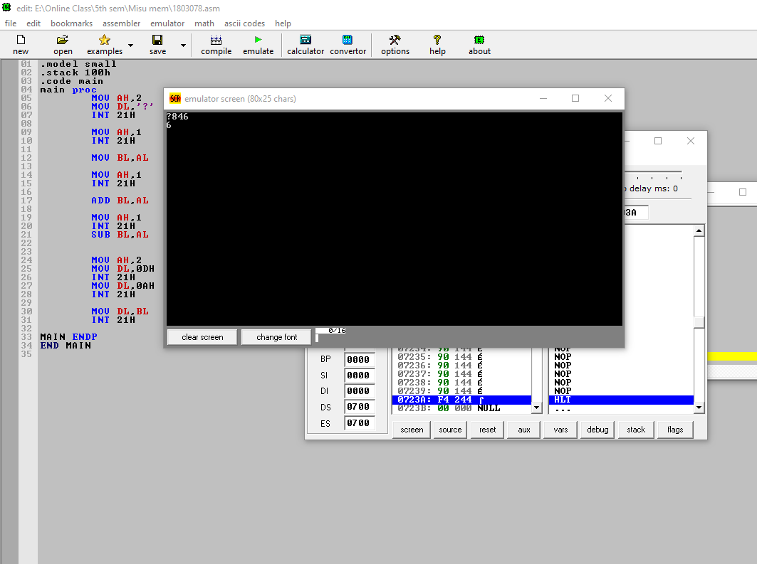

**Discussion :**